Round Robin VS SRTF

Required Comparison Focus
- Fairness versus efficiency.
 | Round Robin | SRTF
Fairness | 1. Short processes are always favored.  2. Long processes may suffer from starvation (they keep getting preempted if shorter jobs keep arriving).  3. A process might wait indefinitely if shorter jobs keep coming. | 1. Every process gets a fixed time slice (quantum q).  2. No starvation → all processes get CPU time regularly.  3. Ensures equal opportunity for all processes.
Efficiency | 1. Minimizes average waiting time and turnaround time.  2. Always runs the process with the least remaining time → best performance mathematically.  3. Overhead due to frequent preemption when new processes arrive. | - Performance depends heavily on time quantum (q):  - Large q → behaves like FCFS (Weak Interactivity and Low Overhead)  - Small q → behaves like RR (Fast Responsive and High Overhead)  - Higher context switching overhead than SRTF.  - Does not minimize waiting time.

- Effect of time slicing versus shortest-job preference
 | Round Robin | SRTF
CPU Allocation | Divides CPU time into fixed time slices (quantum q). | Always selects the process with the smallest remaining time.
Treatment of short or long jobs | Ignores how short or long a job is → even very short jobs may wait for their turn. | 1.Short jobs finish very quickly.  2.Short jobs finish very quickly.
Goal | Fair sharing of CPU | Minimize average waiting time
Effect | CPU time is shared evenly, but not optimized for job length. | CPU time is optimized for shortest jobs, not evenly shared.

- Effect on first response time
 | Round Robin | SRTF
Effect on first response time | Each process is guaranteed to receive CPU time within one time quantum, ensuring that no process waits too long before its first execution. | Prioritizes shorter processes, which means that short jobs can get an immediate response, but longer processes may experience significant delays before their first execution.

- Effect of quantum size on Round Robin behavior
 | Small quantum)q) | Large quantum(q)
Effect | Fair and highly responsive but causes high overhead due to frequent context switching. | Efficient with low overhead but less responsive and behaves like FCFS.

- Whether SRTF gives a strong advantage to short jobs
 | SRTF
Waiting Time | Very low for short processes
Execution Behavior | Short jobs are executed immediately
Fairness | Low (biased toward short jobs)

Testing Scenarios

Scenario A: Mixed workload
Here I'm testing both algorithms on a normal workload with 4 processes that have different arrival and burst times, to see how each algorithm handles a typical mixed case
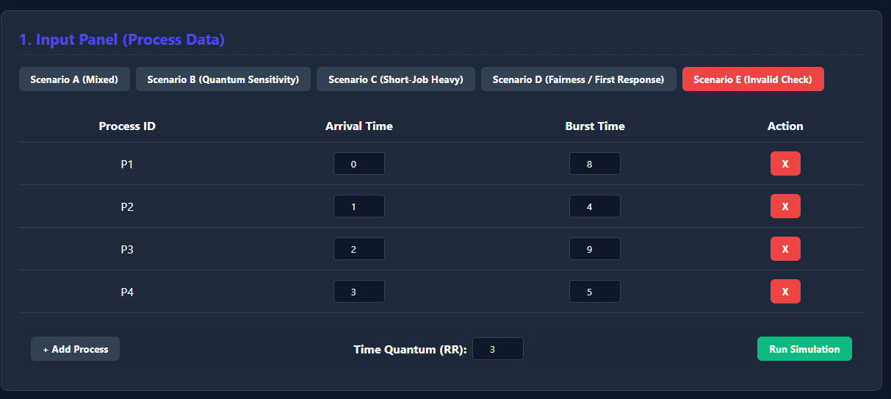
And the results are:
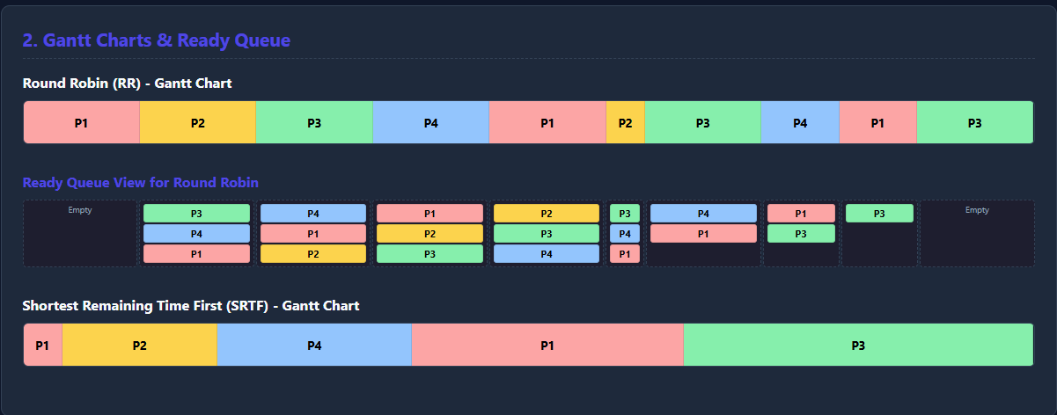


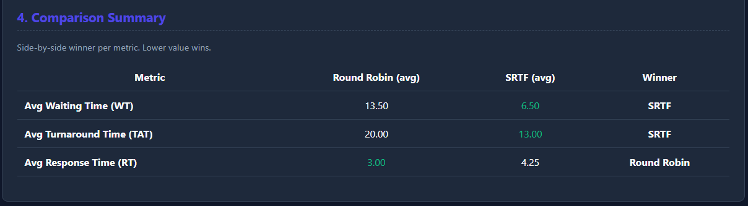

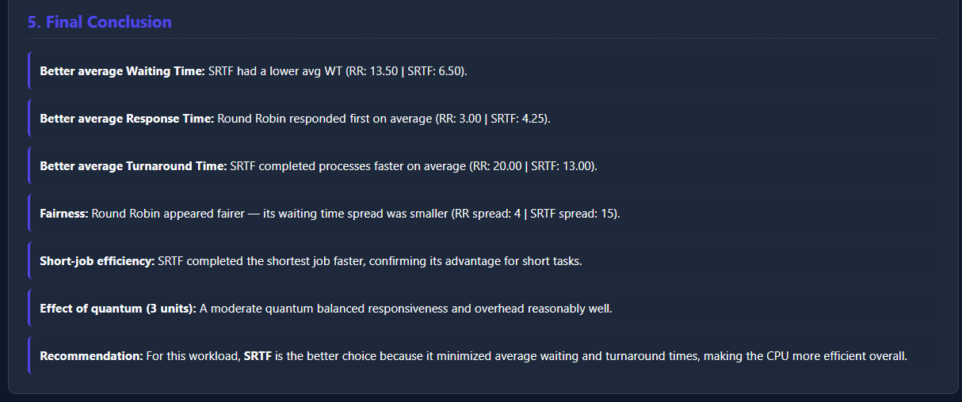
The results showed that basic behavior of both algorithms with varied burst times SRTF minimizes waiting time by always picking the shortest job while RR ensures every process gets CPU time fairly

Scenario B: Quantum Sensetivity Case
Here I'm testing how the time quantum affects RR's behavior by running the exact same 4 processes twice ,once with quantum 2 and once with quantum 6 to see how the quantum alone changes the results

When quantum is = 2:
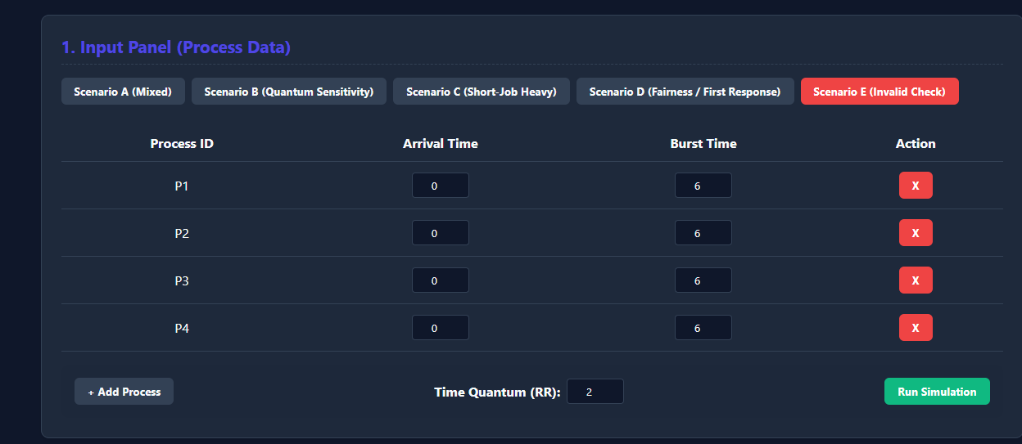
The results are:
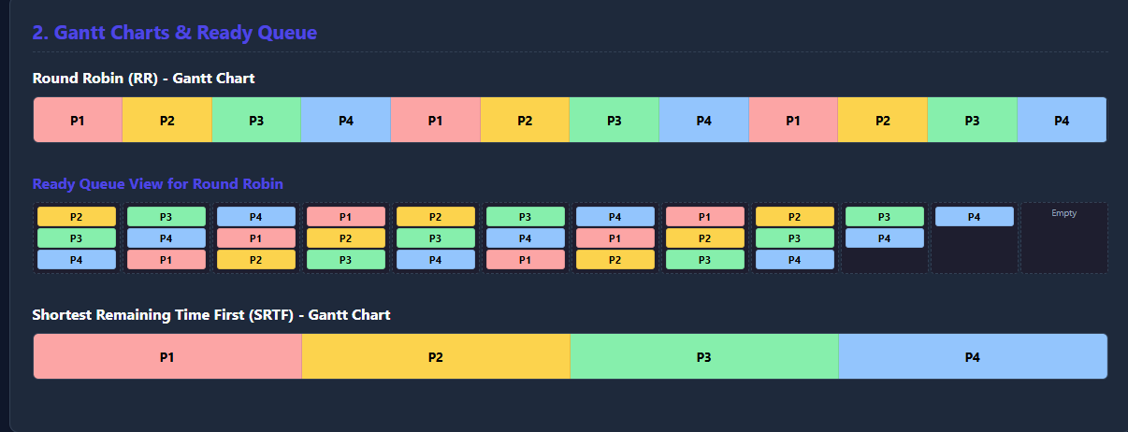


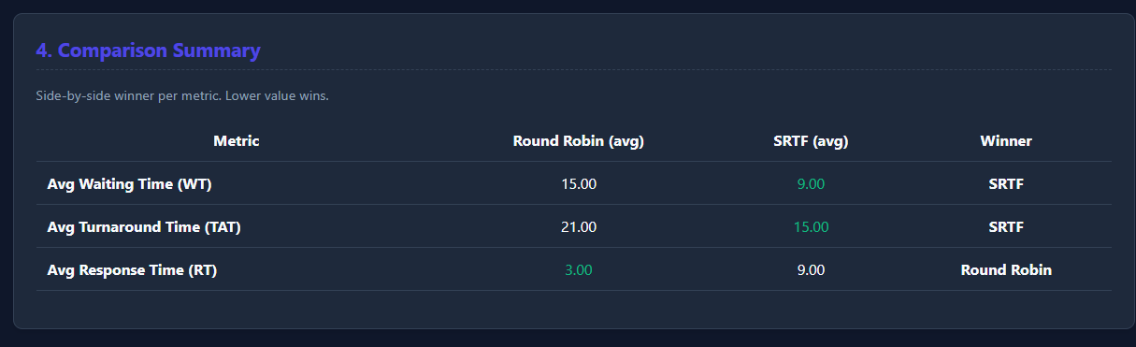
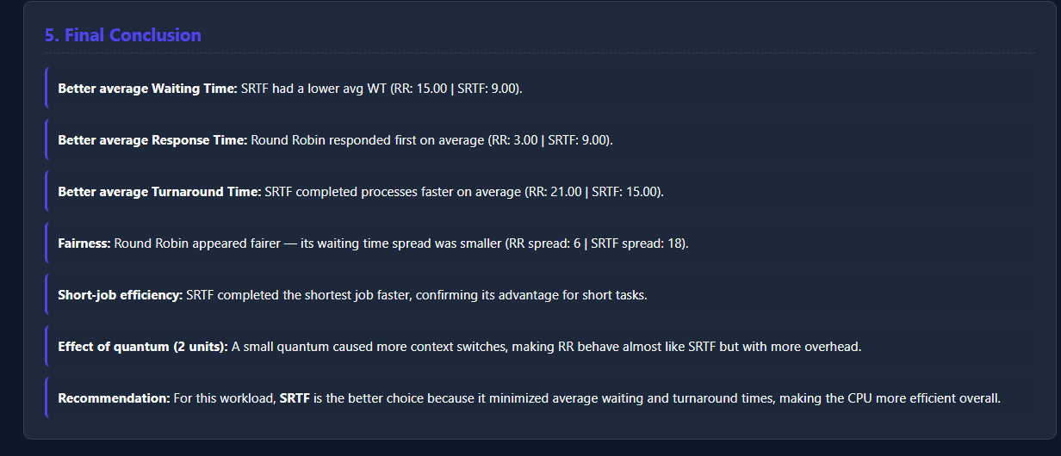
Now we test when quantum is 6:
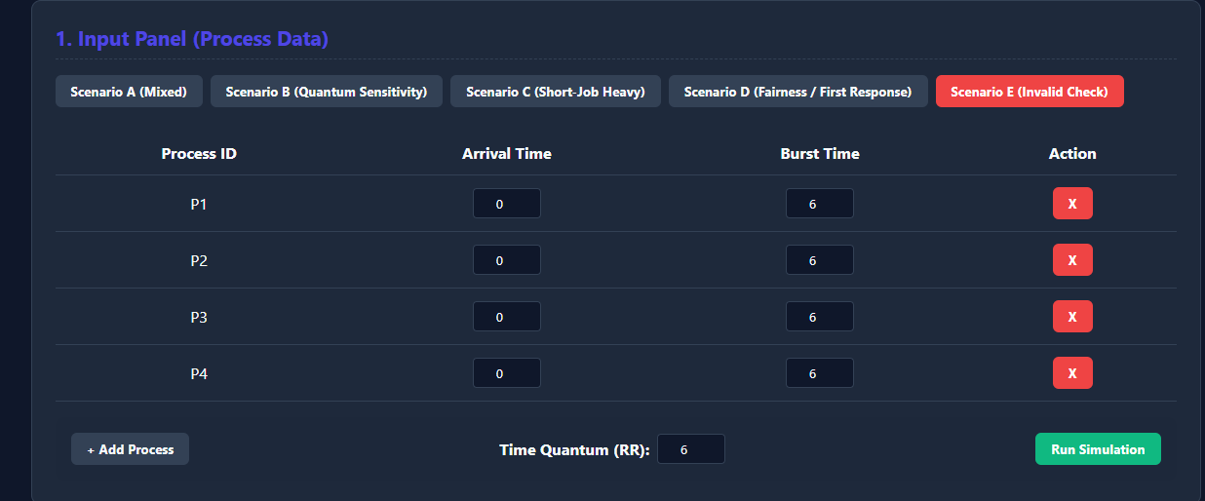
The results are:

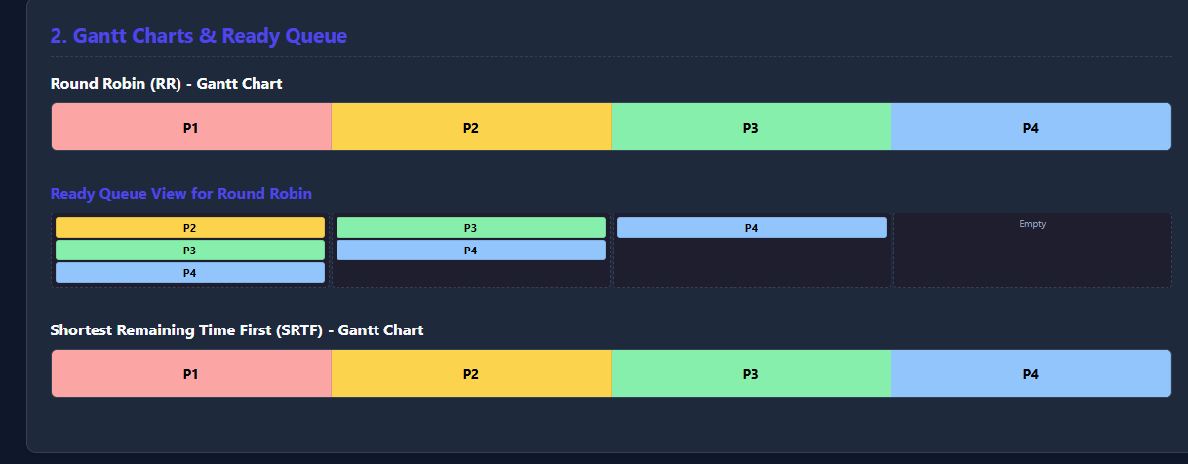

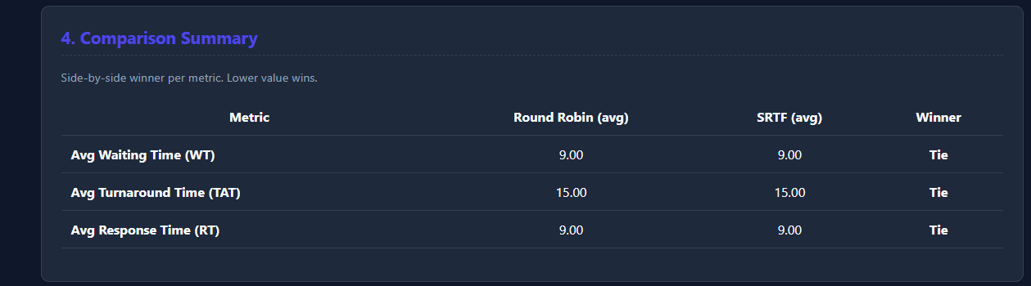
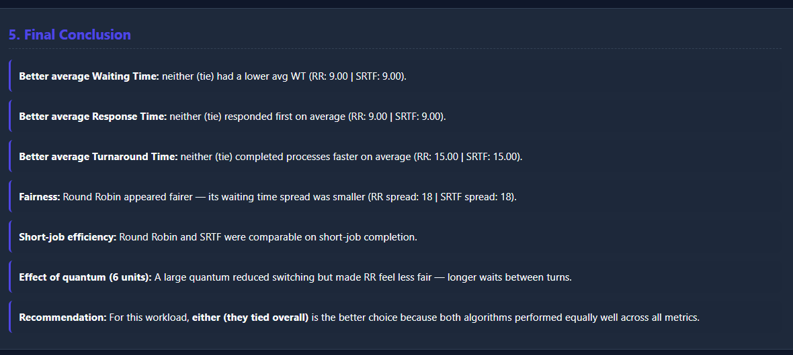
The tests showed changing the quantum directly affects how RR behaves a smaller quantum means more context switches and fairness, while a larger one makes RR act more like FCFS while SRTF has same results in both test cases

Scenario C: Short-job-heavy case
Here I'm testing a workload with one long job and several very short ones, to see how SRTF takes advantage of short burst times by preempting the long job
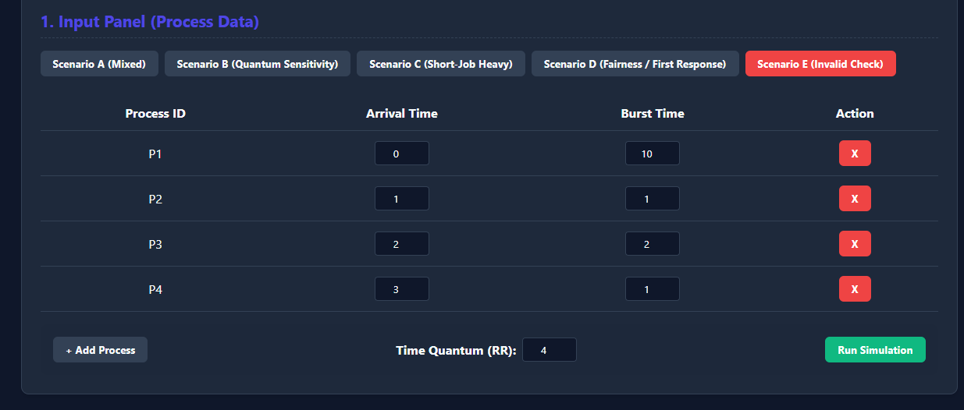
And the results:

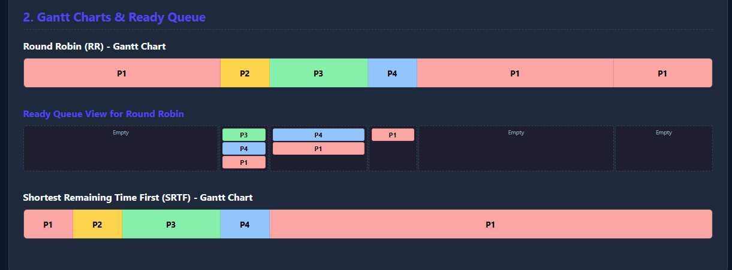


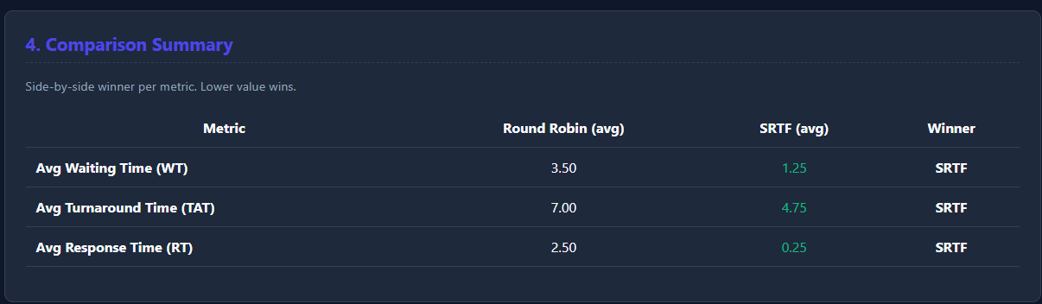
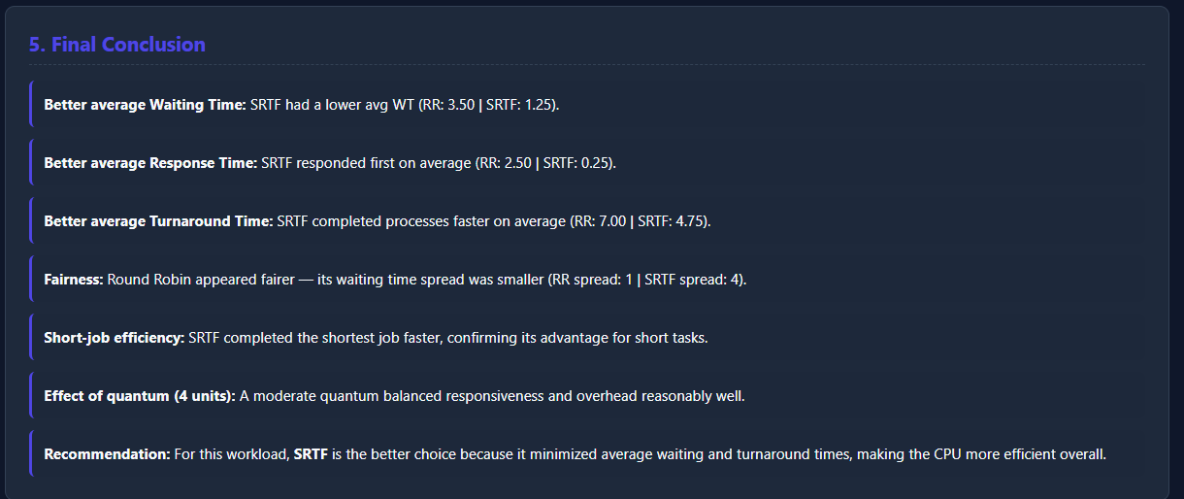
We see that SRTF's advantage is clearly visible here by prioritizing short jobs P2, P3, and P4 over the long-running P1 which significantly reduces average waiting and turnaround time.

Scenario D: Interactive-style fairness case
"Here I'm testing fairness and first response time by having all 4 processes arrive at the same time, to see how RR distributes the CPU evenly with a small quantum
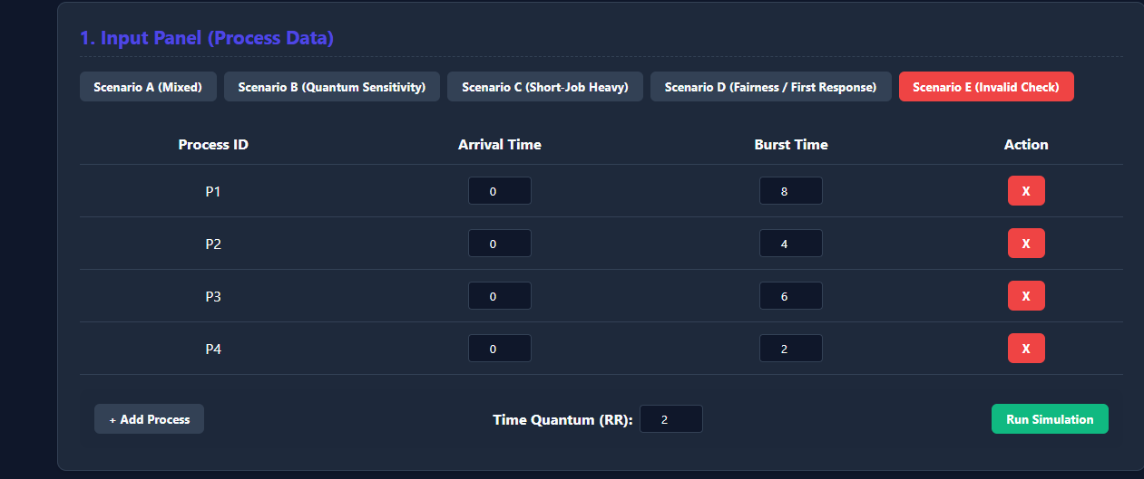
And results:

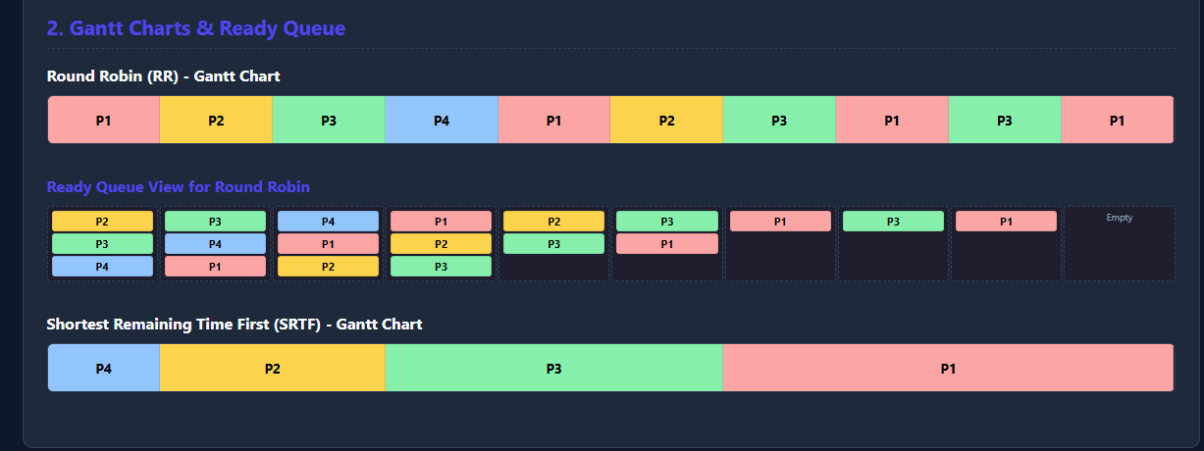


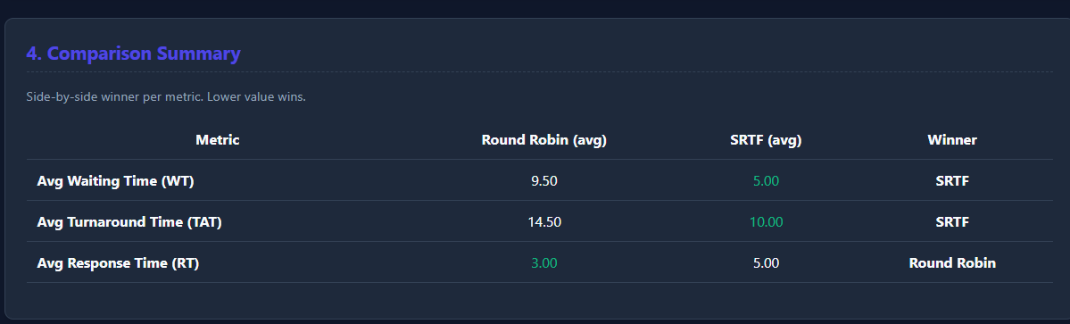
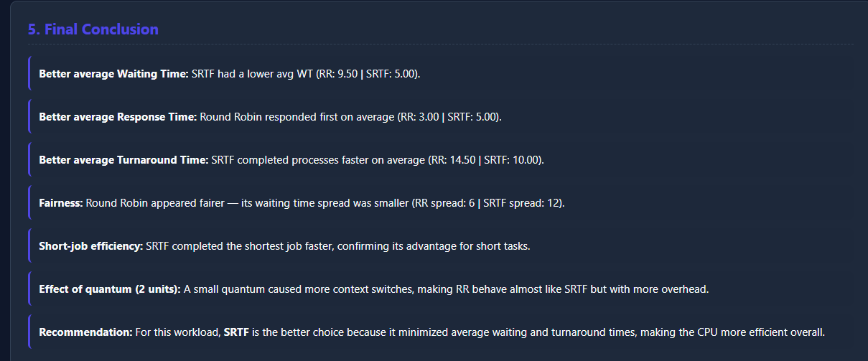 We see that while SRTF might be more efficient in finishing jobs,
RR guarantees every process gets its first CPU turn quickly, which is exactly why it's preferred in interactive systems
Scenario E: Validation case
Here I'm testing the simulator's input validation by entering an invalid arrival time and an invalid quantum of zero, to confirm the simulator catches errors before running
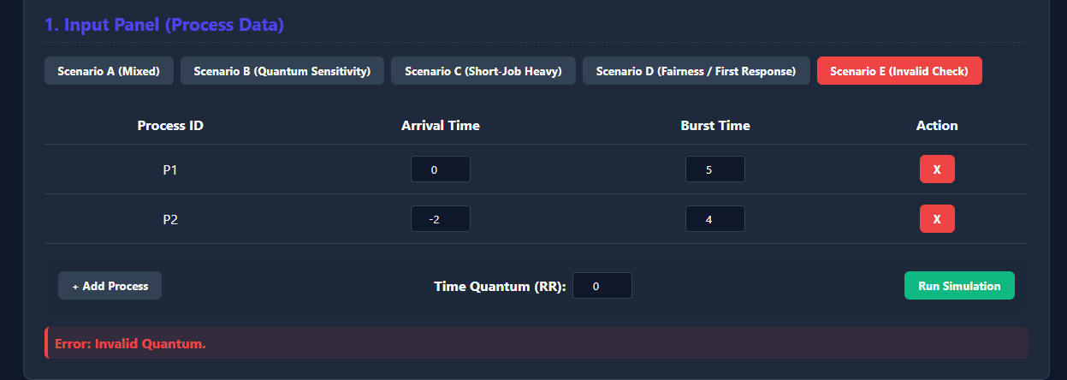
The error appeared

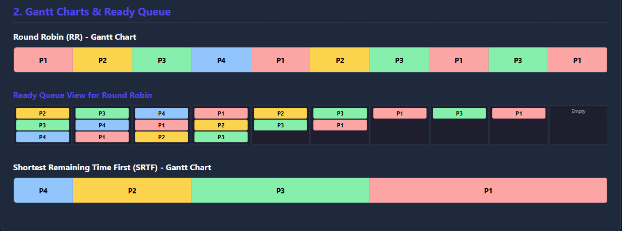

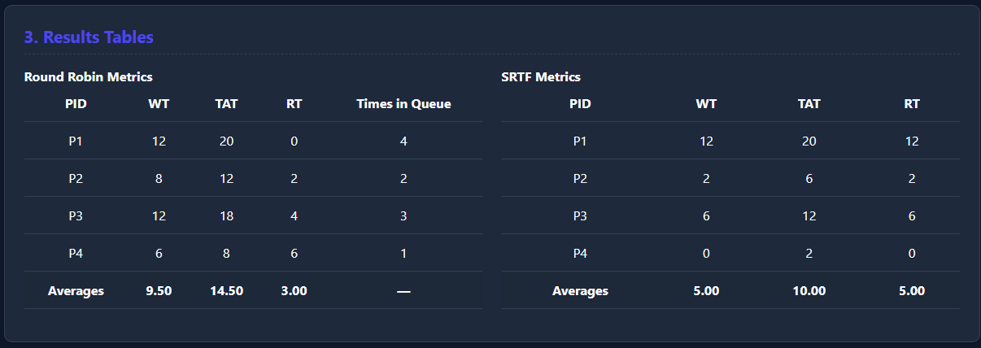
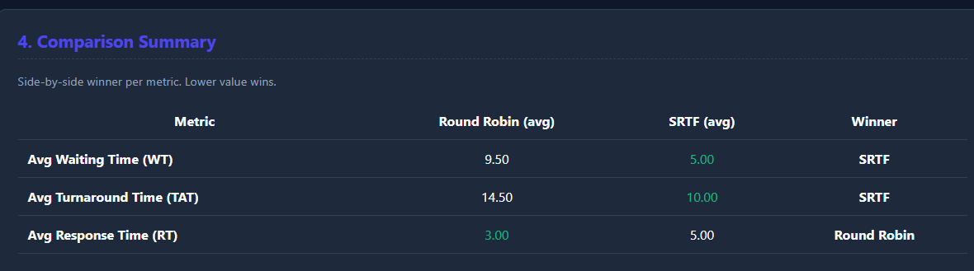
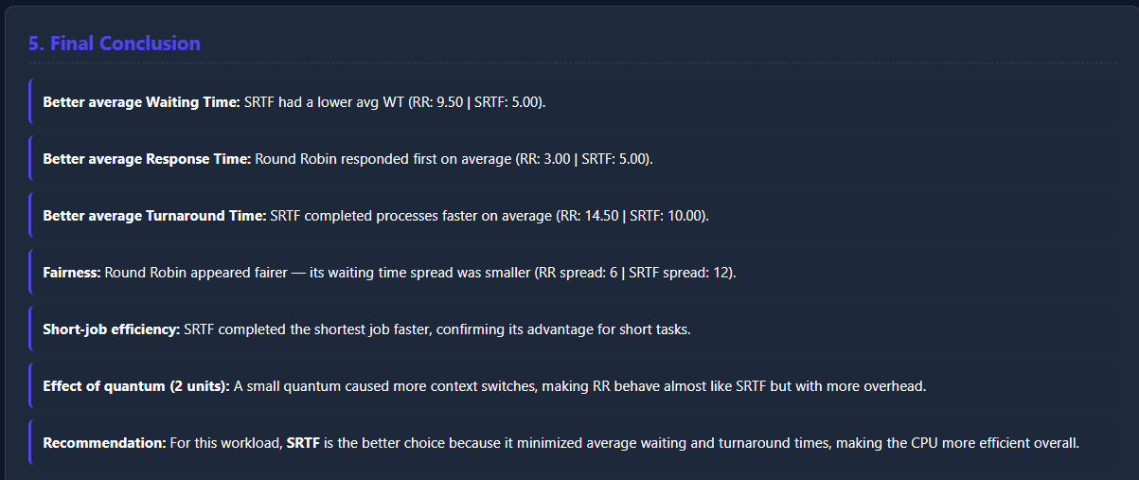
We see that the results confirm that the simulator has a robust validation layer that successfully detects invalid inputs like negative arrival times or zero quantums. By displaying an error message instead of executing the simulation, the program ensures data integrity and prevents unexpected crashes.

Required Analysis Questions
1. Which algorithm gave better average waiting time?
SRTF (Shortest Remaining Time First) typically produces a lower average waiting time. By prioritizing processes with the shortest remaining burst, it clears tasks from the system faster, thereby reducing the total time other processes spend waiting in the queue.
2. Which algorithm gave better response time?
Round Robin (RR) generally provides better (lower) average response time. Its time-slicing mechanism ensures that every process receives a portion of the CPU shortly after arrival, which is critical for interactive systems.
3. Did Round Robin appear fairer across all processes?
Yes, Round Robin is considered fairer because it allocates CPU time equally through a fixed time quantum. This prevents 'starvation,' where long processes are indefinitely delayed by shorter ones, a risk inherent in SRTF.
4. Did SRTF complete short jobs faster?
Yes, SRTF is designed specifically to optimize the completion of short jobs. By preempting longer processes whenever a shorter job arrives, it ensures that minimal burst time tasks exit the system as quickly as possible.
5. How did the selected quantum affect the Round Robin results?
The time quantum is the primary performance driver for RR. A small quantum improves responsiveness but increases overhead due to context switching. A large quantum reduces overhead but can make the system feel sluggish, eventually behaving like FCFS.
6. Which algorithm would you recommend for the tested workload, and why?
If the workload consists of time-sensitive interactive tasks, Round Robin is recommended for its fairness and response time. If the goal is high throughput and efficiency for a batch of mixed tasks, SRTF is the superior choice for minimizing average wait times.

